**REQUIREMENTS**  
Write a python program to replicate a Banking system. The following features are mandatory:  
1. Account login  
2. Amount Depositing  
3. Amount Withdrawal  
Other than the above features you can add any other also.

**CONFIGURATION**

**Added features**

**1.Blance enquiry**

**2. Transaction history**

**CODE**

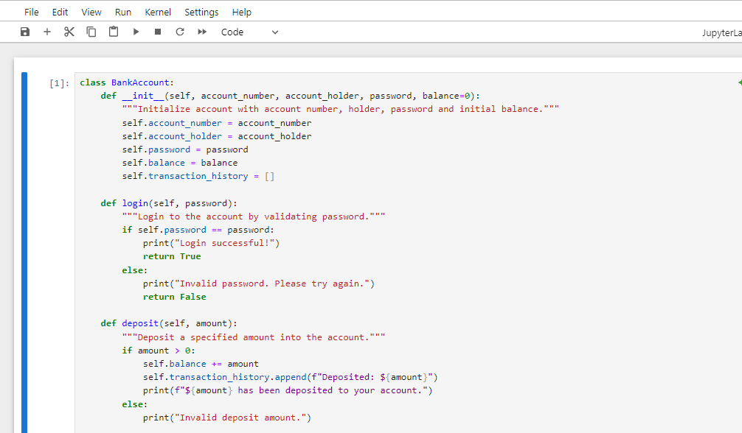

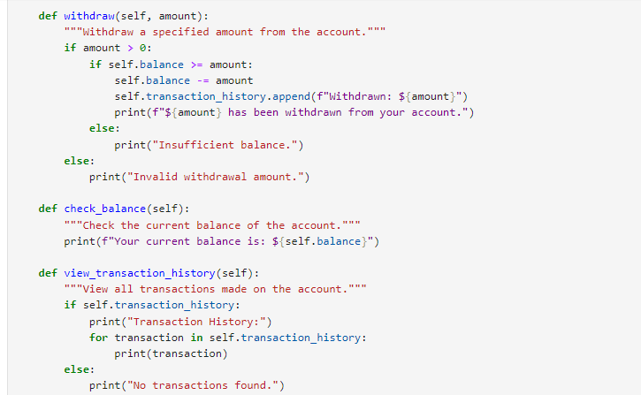

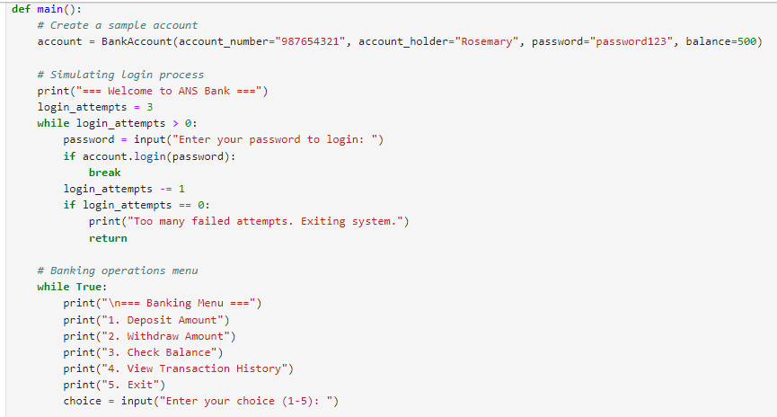

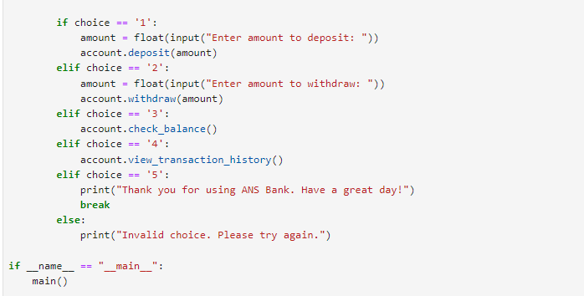

**OUTPUT**

